Attendance

71 General Members, plus Board of Directors Andy Isles (AI) Chair, Jon Tuppen Club (JT)Secretary, Victoria Clements (VC) plus Niall Tanner (NT)– co-opted director

Apologies
Ray and Marjorie Wand, Mike and Karen Watling, Ali Livingstone, Peter Phillips
Karen Turmell (studio), Pippa and Geoff Sheldrake

Welcome to the AGM
The meeting was opened at 7pm by Andy Isles Chair of the Board of Directors for the club who welcomed everyone and gave an outline of the way the evening would run.
Question raised by Graham Fretwell – why was the AGM being held in late September rather than the historic June date?
AI – explained that the departure of the general manager during June following an absence since mid February on ill health grounds, plus other changes in staff had caused significant issues in the running of the club. AI, JT and VC had taken over the managers role between them that then revealed major deficiencies in business process within the club. Board made the decision to focus on stabilising the club and to delay the AGM.
JT – confirmed that this was allowed by the Articles of association which allowed “up to 15 months from the last AGM meeting” and that he had written in June to inform members of this.

Minutes of Last AGM
The minutes of the last AGM were signed as a fair record without question or comment. There are no significant matters not covered by the agenda for the AGM

Director’s reports on the club’s activities for 2022

Andy Isles, Chair, addressed the meeting highlighting the many sporting successes, events and updated members on the plans that had been completed over the last 14 months.
He referred to his report that had been circulated to members in advance.

The last AGM was in June 2023 but due to the significant challenges faced by the Board over the last year, it was decided to move the date of this year’s AGM to 24 September 2024.
I would firstly like everyone to show their appreciation to all the Section heads who have ensured that ISC remains at the top of their sports. All the sections of Tennis; Squash & Racketball; Hockey ; Table Tennis being our main disciplines but I also want to include the good work carried out by those organising Pétanque; Chess; Badminton to name a few. I also wish to mention Karen Turmel for her excellent work in providing 45 quality Studio classes every week.
One of the biggest changes was the departure of the Club manager in February this year. Since then the Board has effectively had to run the club. It soon became clear that we had to address some very serious legal obligations that had failed to be met. These areas included: Health and Safety ( not addressed since 2021), Food and Hygiene ( in particular the Kitchen) , Contracts and Agreements ( not in place) , HR issues and so on.
In addition, the financial position of the Club had become increasingly challenging, as had been previously communicated. Catering had lost serious money, and maintenance had fallen behind. Gym equipment rental costs are still £4,600 per month and it was clear we would not be able to maintain this level of expenditure.
We have moved to reduce salary costs . Thus has been difficult due to the minimum wage increasing by 46% over the last five years plus the addition of Auto enrolment pension costs for the Club. The current staff structure will result in a 10% reduction in wage costs as opposed to the previous 12 months. The Board will have to make further serious decisions in the coming months.
The Board are of the opinion that although we do need a general manager we do not have the resources at present to engage one, and are relying on the volunteer Board members and working parties alongside a strong Senior Management Team.
The Club cannot continue to rely on the goodwill of a few members of the Board.
Energy prices have had a significant effect on the club’s expenses. Our electricity costs have jumped 215% since December 2023. In cash terms this equates a jump from £25,800 to £55,000 (it should also be noted that without the intervention by Board members “ primarily Jon Tuppen” we could have been tied into a contract with Bionic which would have increased costs by 700%) .Jon and Mick Castleton have been working steadily to reduce energy expenditure through efficiencies and the utilisation of energy production from solar and battery storage.
We were faced with two other significant unexpected capital expenditure issues during recent months. The first was following the collapse of our agreement with G4P and the withdrawal of the “One” offer to build at Tuddenham Road after due diligence . We negotiated the purchase of the pop-up padel court from G4P for the cost of £36,000.
I would like to thank the Padel working group for all their work in assessing options for a business case to grow Padel at ISC.
The second major issue was the unexpected complete loss of water to Tuddenham Road which had historically been provided through a connection from the site in Gresham’s. Mike Watling and Jon Tuppen , along with our contractor, were able to miraculously restore this supply in four weeks ( 3 months before Anglia Water estimated) , but at a cost of £33,000.
At present without an inflow of capital we are unable to embark on any further major projects. Any plans for the new studio and the changing room projects will be discussed with the new Board at our next meeting, but are currently in abeyance.

Although we are facing these financial challenges and we have made cuts wherever practical, we have been able to continue with the original capital programme. On a more positive note we feel we are still maintaining top class facilities for members.
The work at Tuddenham Road has now been completed. We are pleased that the Luke Chambers Academy is utilising and paying for the use of the pitch . The Academy will also be using the grass area for further training. The Car park is complete, and the club house has been painted and refurbished. This is an area open for hire and can be marketed. The bar has re-opened and last year made a small profit.
At Henley Road the outside area is complete. Pétanque is very popular and the new paving ,landscaping , seating and outside bar have been well received and provides a lovely ambience for families and with good weather will become a focal point for the club. The area is also open for hire.
We have agreed to carpet and paint the Bar area which will be carried out in October.
We believe we have finally agreed a format for Food and Beverage which will enable the club to provide meals regularly and take bookings for functions and events from September.
The Club will be expanding the food offering during the day and staff are being trained in basic food handling. Many thanks to Dariusz and Gill for their hard work in stepping up to support the Club over the summer and working with Jon to find a catering solution and also for securing our 5* rating for the kitchen.
Communication between Council, Board and members has been very positive . The Council Chair has attended Board meetings and many of the Council members are volunteering to assist in working groups and administration ( in particular Penny and Heather).
Membership has increased this year by approximately 5% alongside income.
I would personally like to thank the staff at ISC who have worked professionally and diligently in maintaining the high standards at the club and addressing members’ needs in difficult changing and challenging times.
The Senior Management team now has a new addition with Emily Ison agreeing to take the role as Sports Co-ordinator , this is a contracted role with a specific job description. Emily is well known at the Club having a long 25+ year association with ISC both as a member and head squash coach. We welcome her to the team.
Accounts for year ended 2023 and Treasurer’s Report
AI – acting Treasurer presented the outcome position as per the independent auditors reviewed accounts which had been distributed to members, along with the Treasurer’s report.
This report will primarily address the position to 31 December 2023.
We are posting a loss of £170,075 for the year as opposed to £236,849 in 2022. This was our first full year without covid restrictions and although the membership has recovered to pre covid days the income generated from membership and bar does not equal costs.
The overall loss before depreciation was £19,624. We do not expect 2024 accounts to show a significant improvement.
As explained costs have risen significantly. Although we have invested c£100k in solar, new boilers etc this has addressed the increases we would have faced. (it is estimated our utility costs would have increased c £4000 per month) .
Food in particular continued to lose money just on a direct income cost basis, not including costs of administration, utility, cleaning. In February Mo resigned and the Board and working committee took the decision to move away from direct employment to a franchise. We have been working with Dariusz and Gill to find a food offering that will meet the needs of members and this has finally been approved.

The Bar sales have remained stagnant and with rising costs it is difficult to cover for bar and reception costs. The club is open for 105 hours per week. Bar staff cost an average cost of £13.50p per hour ( to include pension, holiday and NIC) it is not hard to see how costs have risen as to have two persons covering it will cost £150k per annum.
Other costs, as we all know, have increased whether it be cleaning or maintenance. Our maintenance at the club has been neglected for many years. The programme set about restoring, renovating all areas across the club. We have, however been faced with exceptional increase in costs for maintenance issues that have to be resolved apart from the ongoing general repairs admirably carried out by Richard. A few examples of maintenance still to address : Indoor tennis roof -£10k , Drainage at HR, as yet unknown, Cladding on Court 7 - £4000, New front doors, Bar area.
We have changed our cleaning contractors and moved away from Phosphene marketing. Marketing is now in house with Helena who works 4 days per week with digital marketing and Helen who organises our networking events and to bring in sponsorship to the club.
We have been faced with other additional costs including the Chris Grimwood case.
I am positive about the future now as our staff have been devoted to the improvement of the club. Now we have the food offering and the bulk of the maintenance work complete we can move forward positively. I would personally, as acting Treasurer, like to thank the Senior management team of : Anna ; Lauren; Helena ,Simon and Jamie . In particular Anna who has conscientiously been at the hub of all the financial pressures we have faced and always offered professional and welcome advice and assistance.
AI also ran through the use of capital funds, unexpected major expenditures and the projects still needing funding. The figures were presented to the meeting as a presentation.
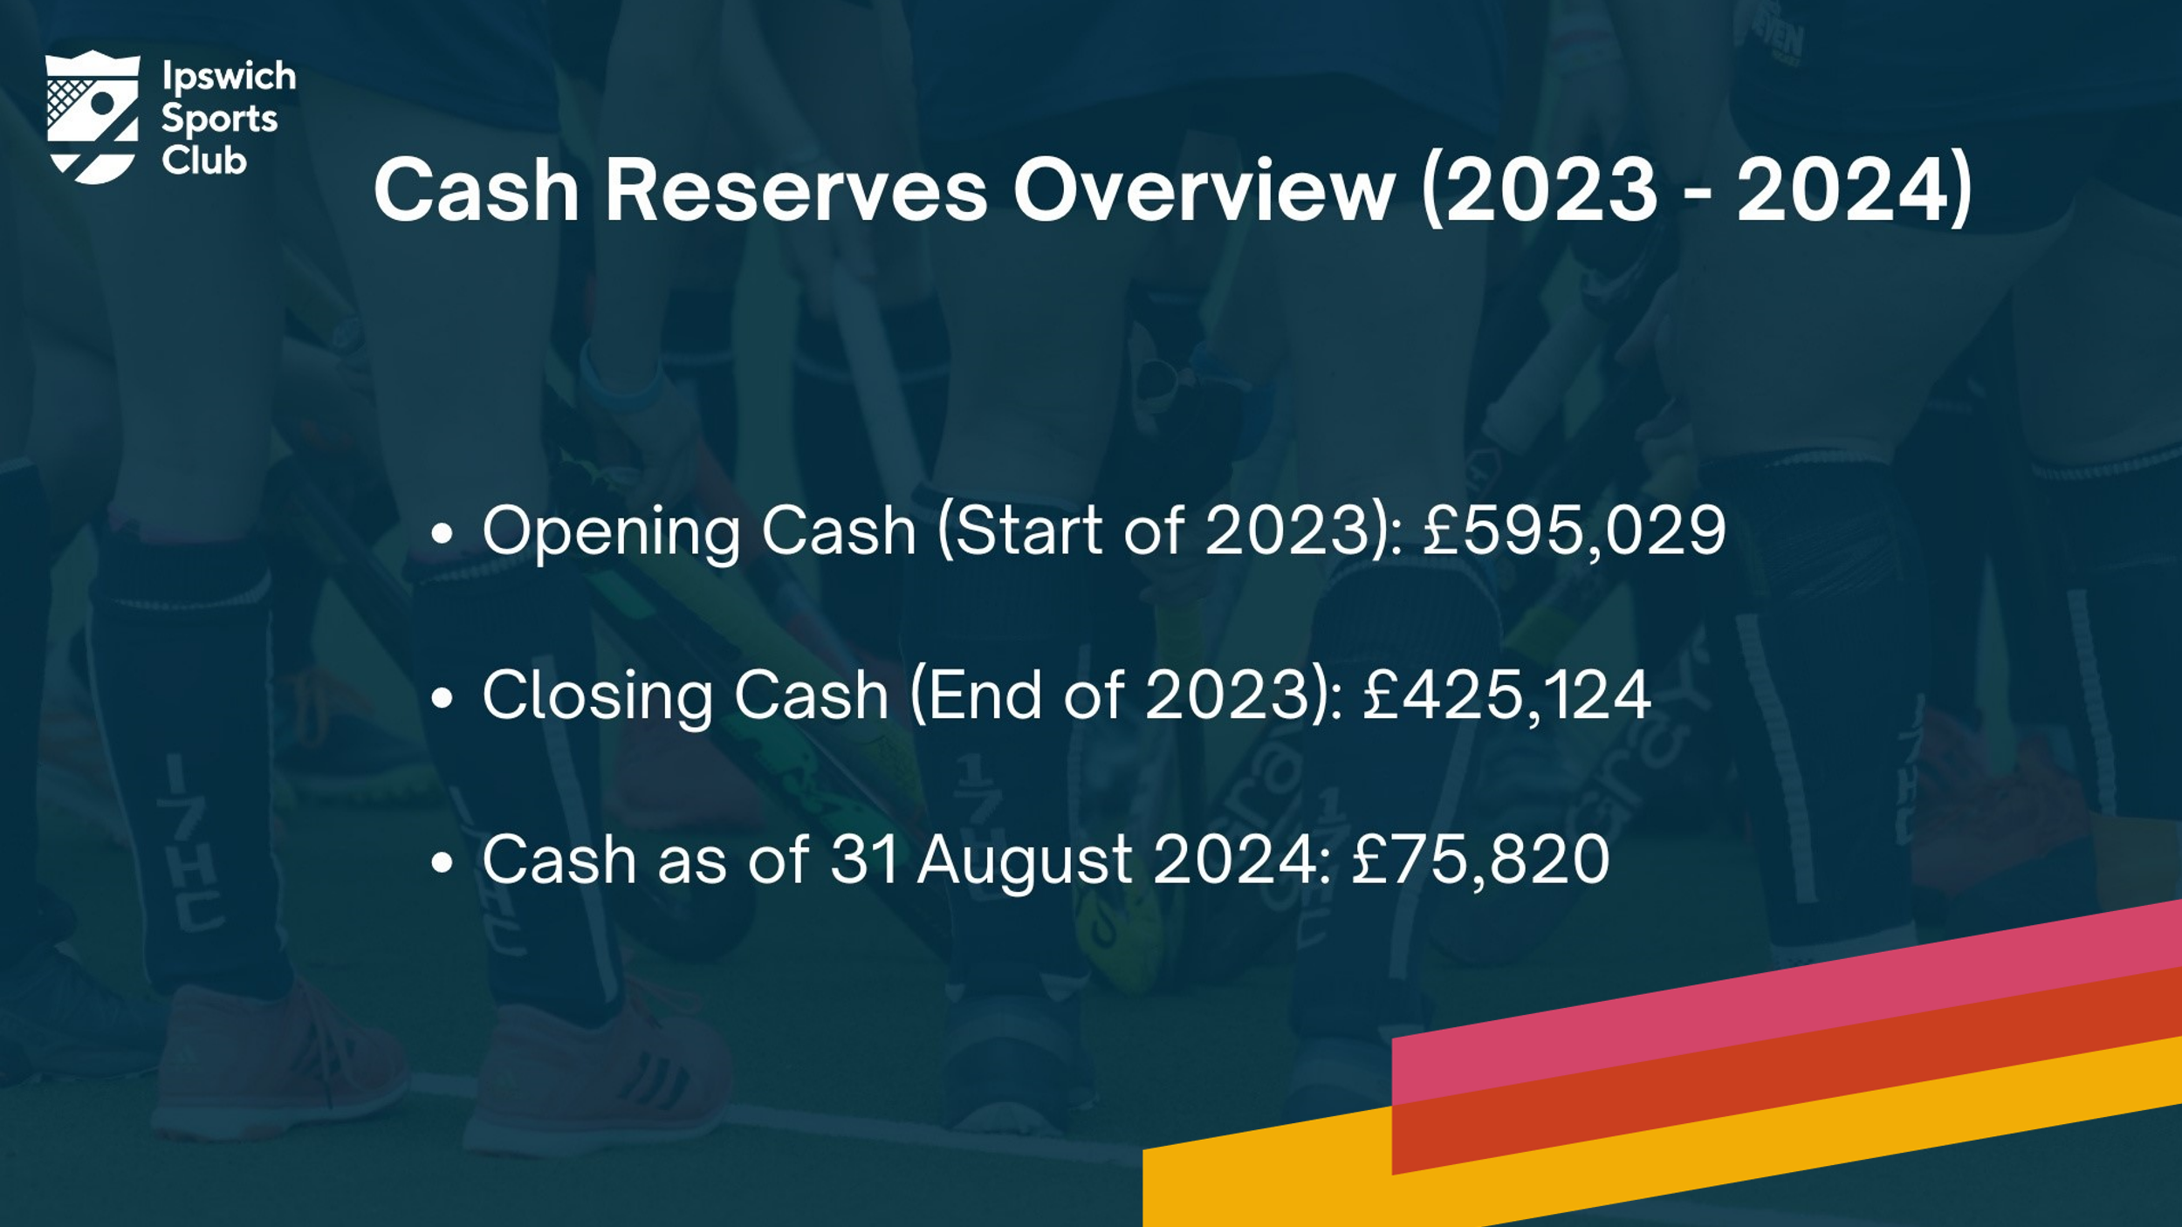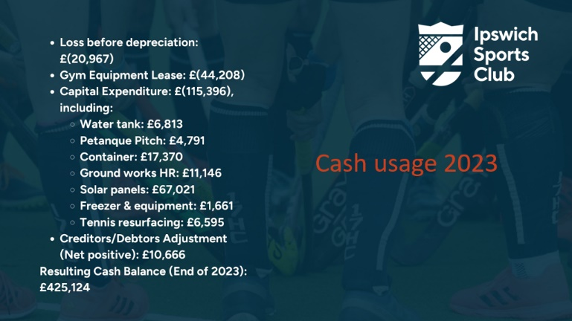

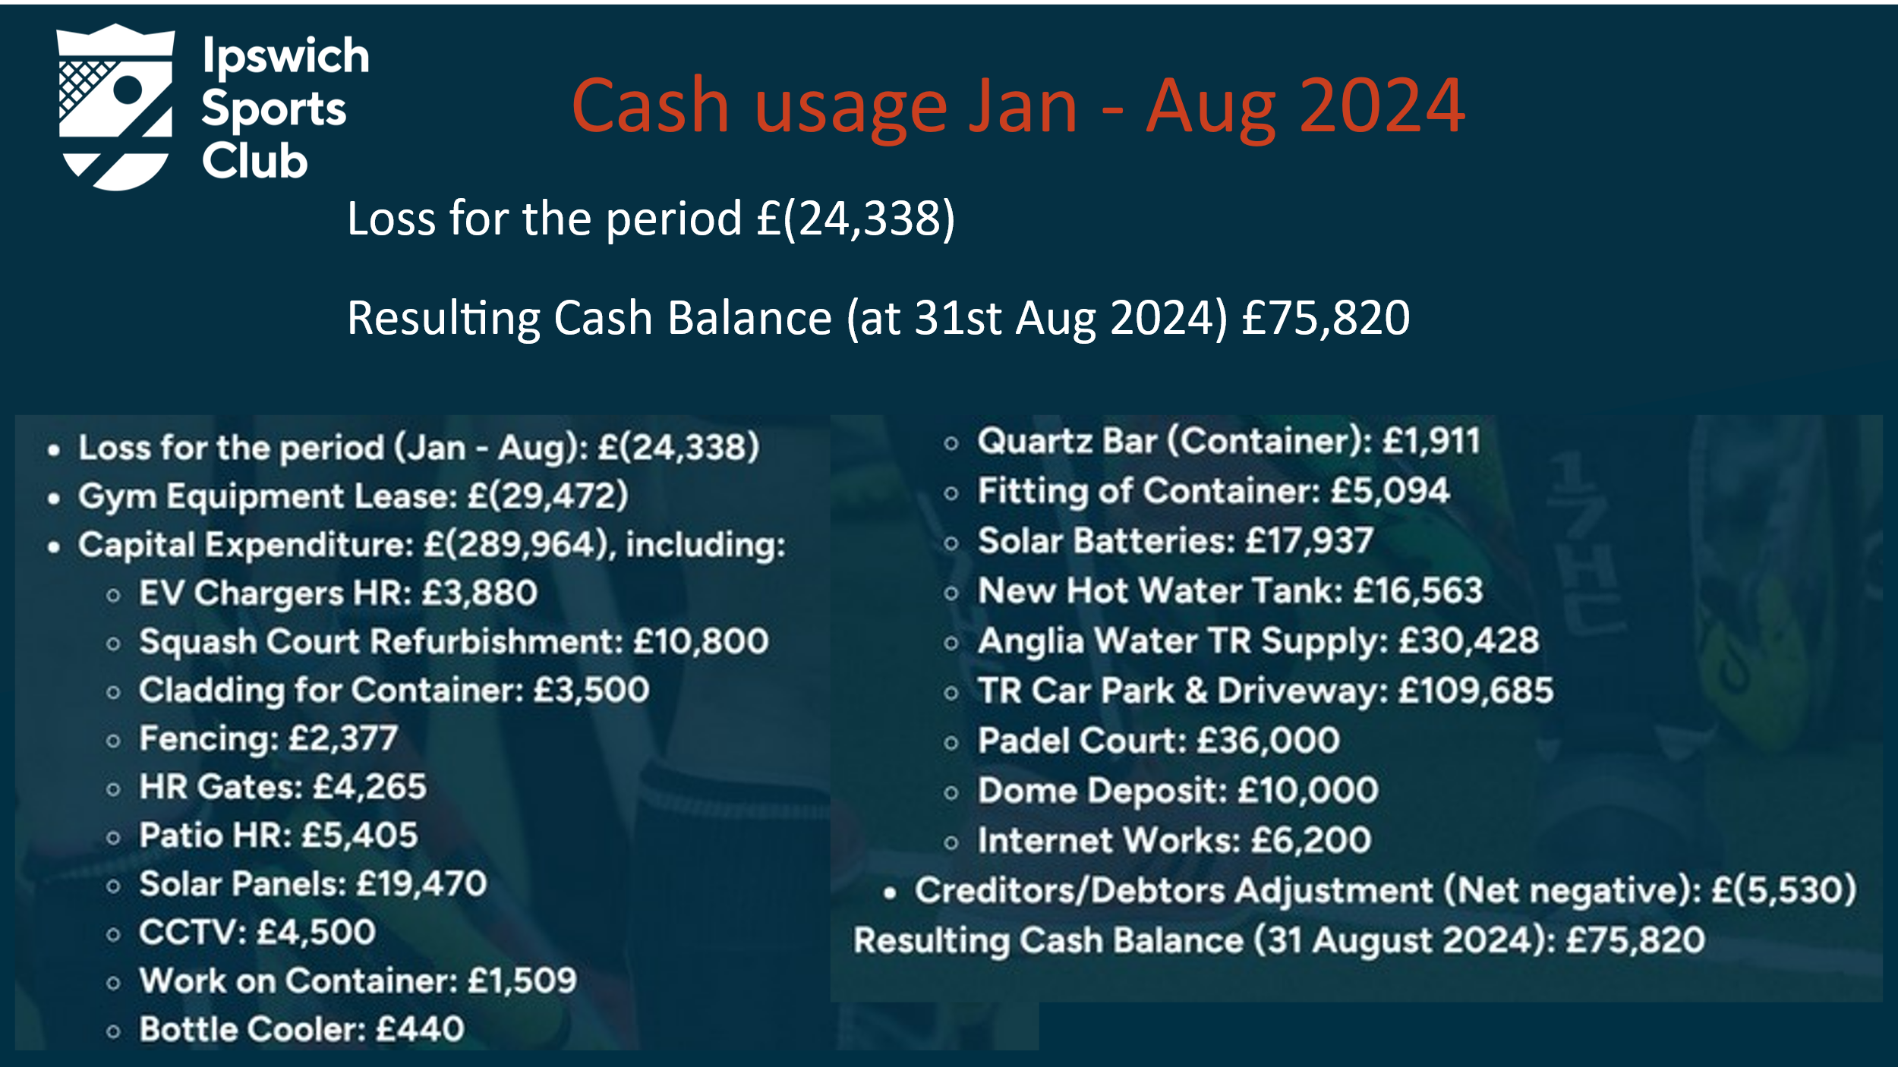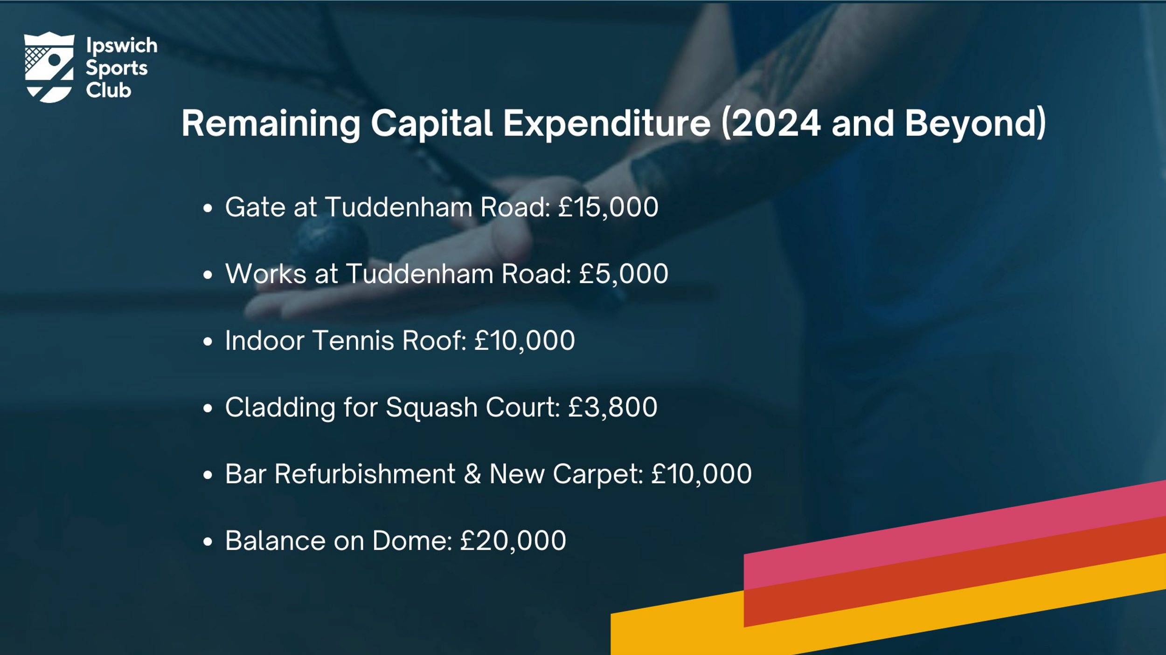

Question/ Issues raised by Mark Cracknell – a caution to the Board and members about putting financial details onto the open website.
AI – agreed in principle and pointed out that the clubs accounts were posted at Company’s House
NT – also advised members that as part of a broader IT review that included governance he was hoping to find a method to have more confidential matters protected behind a members only section.
Question/ Issues raised by Dave Howell – what rate of interest is ISC paying on loans?
AI – there is only an LTA loan outstanding at 0(zero)% . He is certainly planning and hoping not to have to go for loans for day to day running of the club. Only loans backed by a proper business case would be considered – eg Padel changes and investment in a second court.
Question/ Issues raised by Craig Clarke – Where will the money for padel come from?
AI- The padel working group will develop a proper business case. ISC 2020 Ltd must remain CASC complaint. AI explained that he is taking advice from a CASC advisor about setting up a separate company so that non-member income does not exceed £100k in total. At present padel is netting 4k per month and is well on it’s way to recouping the capital spent.
Question/ Issues raised by Mick Castleton asked what numbers of people were using the padel court.
AI – there had been over 800 individual users of the court. Of those 200 were members of the Matchi system now run by ISC. Of those 200 , 180 were not members of ISC itself – yet!
Question/ Issues raised by Peter Richards – thanked the Board for the information to date but asked what the overall business strategy was
AI and JT advised that the strategy was based on areas such as focused Marketing -returning from just being web and social media focused for a while, increased membership of up to 400 more, a return to some form of food on site which could even return a small profit, and a review of Subscriptions. In addition we now had Padel income flowing in and the Board was aiming to exit the gym rental agreement at earliest opportunity - we are currently committed to £4.5k per month purely on rental.
Question/ Issues raised by Fi Cable – agreed to changes in marketing and asked what the marketing budget was
AI £30k per year and that staff had been allocated to the ISC marketing strategy
Clive Johnston – advised making use of the Suffolk Show and similar events to show off what the club does and to market ourselves

AI asked the meeting to receive presentations by JT regarding ISC energy strategy and on Food strategy before asking more questions.

The Energy presentation showed a large drop in energy purchased from the grid, but despite this a doubling of energy costs.

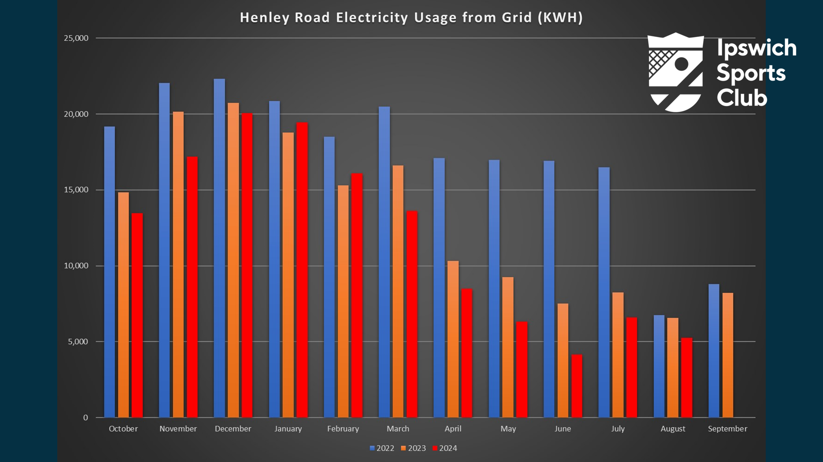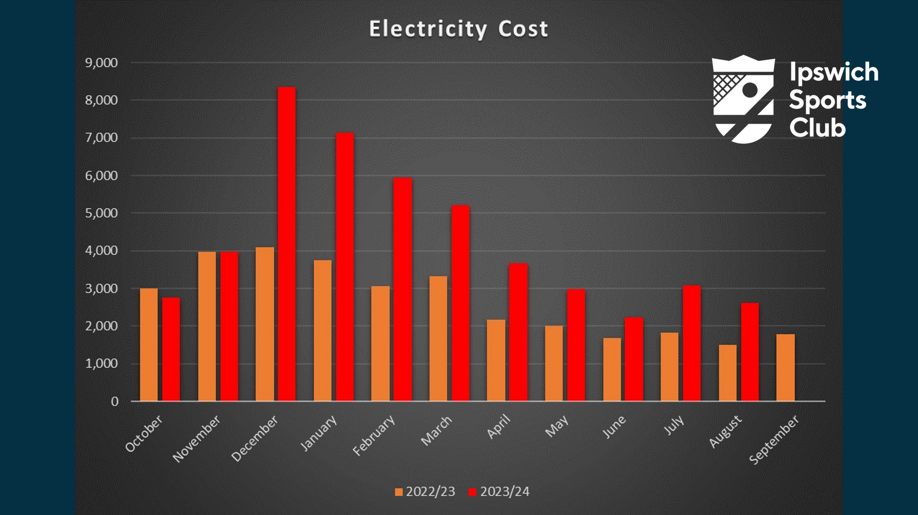
JT also demonstrated the relative running costs of the indoor tennis courts v squash courts and advised that a working party was looking at ways to save money and share costs effectively (as well as reviewing and updating tennis booking policy).
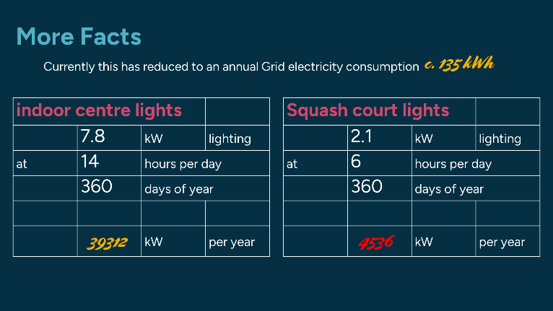

JT showed slides explaining the legacy problem with an un-traceable owner of the PV array on the tennis court centre roof that meant ISC was not benefitting from excess energy produced. It is crucial that ISC uses as much energy as possible from the PV production. Investment has been made into dynamic management , batteries and water heating with more possible if funds allow.

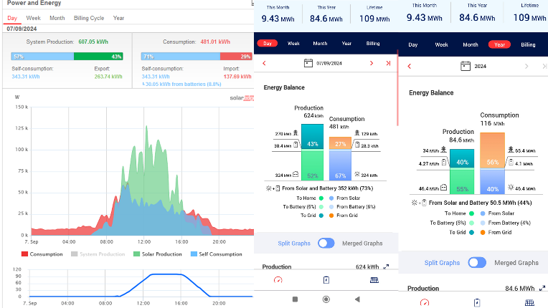

JT also presented the results of the food survey and advised that the food strategy is finally taking shape and is set out as
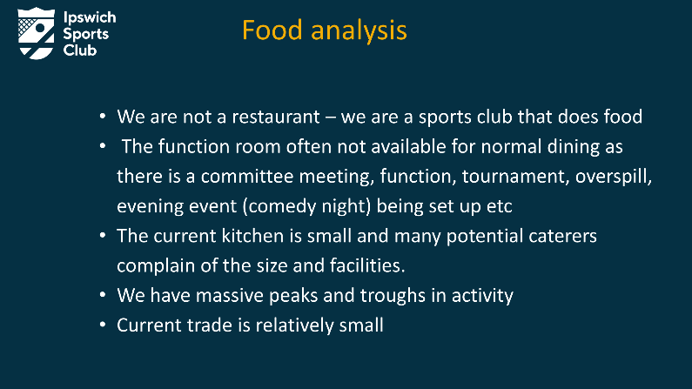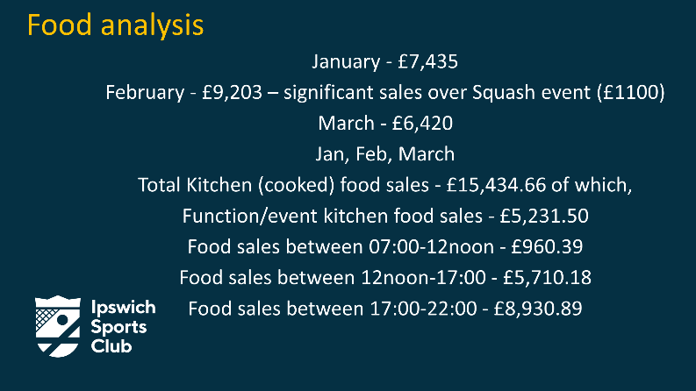
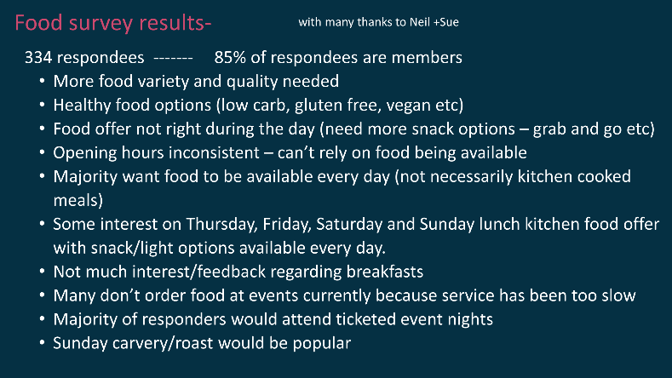


This strategy should give less dependency on any one provider with more choice and variety of food. It would also mean that ISC doesn’t employ staff in slack or non -commercially viable times and give an overall better utilization of staff resource with possibly a small profit.

Club Auditors / Independent Accountants Review
AI explained that Council and Board had discussed the need versus cost for a full audit. A joint Board / Council decision was to have a full audit every 3 years , with cheaper independent accountant reviews every year . Dick Partridge proposed a motion that GMS FC Ltd (the Club’s current auditors) should continue for 2024 and this was seconded by Mick Castleton. The members present voted unanimously in favour.

Board Director Positions

Andy Isles, Chair, and Jon Tuppen, Club Secretary have a further year remaining in their 3 year tenure.
JT took the meeting through the remaining nominations and split this into 3 sections.
- Victoria Clement has come to the end of her first 3 year tenure but has stood for re-election. Board supports recommends the re-election of Vic particularly with the recent turnover and turmoil. The AGM unaminously agreed and elected Victoria Clement for a 3 year tenure
- Niall Tanner had been a non-voting member of Board since Council elected him as Chair of Council a year ago. July 1st he resigned as Council chair to be co-opted as a director of the Board. He is standing for a 3 year tenure. Board recommends AGM support this. The AGM unaminously agreed and elected Niall Tanner for a 3 year tenure
- The articles of association states 35.1 The number of directors shall be not less than 4, and unless approved by ordinary resolution, no more than 6.
There have been 3 applicants who have passed through the application process. All have good attributes and all have a significant number of proxy votes in their favour. With club running without a general manager and being managed by AI and JT at present and into the foreseeable future the Board presented a motion for an ordinary resolution allowing “a temporary increase in directors from a maximum of 6 to 7 – the duration being until the next resignation or retirement of a director”. This motion was duly unaminously carried by the meeting and Chris Dearling, Alison Hosford and Hollie Newton were all elected as Directors of the Board.

Election of Council Members
JT reminded the AGM that at AGM 2023 a special resolution was passed changing the voting process and number of members at Council. This was passed and the Articles of Association have been updated with these changes.
As a result 4 new General Member posts were created and the following members were chosen and co-opted onto the Council,
- Heather Beaton
- Mick Castleton
- Sue Stenson
- Penny Whittaker

The AGM 2024 elected all 4 members.

JT also reminded the meeting that a vacancy already existed as Niall Tanner- General Member had resigned his position as previously explained. An election process would therefore be run by Council in due course. Other changes to Council follow changes in elected Chair of Sporting Sections

Question from Members
Question/ Issues raised by Graham Fretwell – GF had noticed a line in the accounts as redundancy and asked for explanation and costs to ISC related to this
AI answered that this was the entry used in the accounts and agreed with the independent accountants. It related to the departure of the General Manager (Chris Grimwood). Costs were as per his contract.
JT advised that members should be assured that as directors had been acting as General Manager on a free and voluntary basis and would continue for the coming months, the Club would have net financial benefit – to the tune of more than £10,000.
Question/ Issues raised by Suzanne Collis – suggested that in her opinion subscription fees, especially for the Gym and Studio were excessive. Her comparator was J D Sports.
AI answered that members were free to choose where they went, but that the club has significant other social benefits with a bar and soon food again, plus a wide range of other sports to benefit from
Question/ Issues raised by Adrian Howell – asked that more be done to keep members up-to-date.
AI replied that this Board had tried to be as open and transparent as possible. Getting communications right was important. The Chair sent out fairly frequent updates throughout the year, articles were put in the weekly newsletter and this Board had initiated quarterly “meet the Board” forums. The latter were widely publicised but often only had a handful of members. In addition members had been invited to join Working Groups looking into Padel, Food, Gym and Studio and more recently Tennis Indoor Centre lighting fees and booking policy.
Question/ Issues raised by Peter Richards – returned to his issue about the Strategy for the club. He certainly acknowledged the amount of work done and was far more knowledgeable after tonight but still wanted to see better Strategy from the Board.
AI and the Board replied that that is certainly where they want to get to. Over the next 6 months it was important to transition from firefighting and performing the role of General Manager to being strategic leaders. Board was aware that part of the reason for the last 2 General Managers leaving was that the workload and breadth of issues in this complex club was too much for one person. Therefore, we were trying a different approach with a Senior Management Team (SMT) taking separate areas of accountability. The mangers involved are – Anna for Finance, Lauren for Membership and Booking, Simon – Operations manager, Jamie - Bar manager, Helena for media and marketing and Emily recently for Sports co-ordination. SMT met regularly – often with a director present.
Emily Ison in the audience – agreed to the above points and confirmed that SMT wanted to free the directors up for Strategic leadership.

Question/ Issues raised by Dave Howell suggested that the club was missing out on income from hiring the function room particularly on a Saturday evening. Googling local event rooms for hire did not show ISC. He advised even making the room free but taking the profit from the bar.
Acknowledged and will be considered.
Question/ Issues raised by Vanessa Penn – asked why Game4Padel had not worked out as hoped
AI G4P had been unable to make the Tuddenham Road site work for them financially which ultimately led to us buying the court and business
Question/ Issues raised by Vanessa Penn – asked what was planned for access control in order to protect the club from non-members ( or lapsed members) using the facilities.
AI Board had been advised that even with an expensive re-configuration of the reception area the turnstiles could not be made to fit into the room available. The current thoughts Board wanted to do sooner rather than later was having access control at the doors to the Gym, Indoor Tennis Centre and Padel court, with a general log in at reception area for other activities and for a log of people on the premises.
Question/ Issues raised by Ian Bullock – advised the meeting that he disagreed with Suzanne Collis about the value for money. He advised that he had brought many pétanque players to use the facilities and many had joined as social members. Members had joined up to age 95. He thought the facilities and approach of the club was very good. He also reminded members that he had donated a considerable amount of pétanque equipment and was willing to coach or support anyone wanting to learn
AI – thanked him for his words and certainly welcomed all people in newer sports such as Pétanque, chess and the social “pongers” to the club.
Question/ Issues raised by Alonso (Henry) Paez Ramirez – pointed out that a lot of time and money had been invested into the Tuddenham Road site and suggested that many people didn’t go there or even know about it. What was going to be done to make this better integrated into the club and make it part of “our club”?
AI Suggested all members should try the improved facilities and understand it better. Emily advised that this was certainly on her To Do List. For example, members should make a visit to watch some Premier League hockey and to utilise the improved bar. Luke Chambers Football Academy had also brought extensive further footfall to the club and had introduced Tuddenham Road as a site for a Running Club. The club house already hosting parties (children to date) sometimes with hire of the 3G pitch. VC agreed and suggested that the hockey players were a friendly social lot who certainly enjoyed a drink after matches – so go and join them.
Question/ Issues raised by Graham Fretwell – Finally, what would success look like in 2 years?
AI a thriving , financially stable club, putting money aside for future investments. This amounted essentially to more members (up to 400) paying more than the average £27 per month at present. NT advised that things were complex – although we all sat under the ISC umbrella we of course had somewhat disparate sporting sections, gym , studio and padel under it. Council and Board are working on a joint development day looking at this very issue and digging deeper into the financials of the club. Any particularly skilled or interested members are welcome to make themselves known for inclusion.

JT thanked the audience for a respectful, friendly and very useful meeting.
AI closed the meeting at 20:52

Written Questions received in Advance

